Metal and Stone

Juventas et Patrius Vigorous.
Youth and Patriotic Vigour.
Agwii’ idiwin, Tratii,
Treaty.

Athena enshrined.
Trident, shield, centurion’s helmet.
The lion, the lord, the guardian.
The conquerer and the conquered.

Bend your knees. Bow your head.
Sit at the right hand of your Queen.
Suckle at the breast of your mother,
She who lives across the big sea.
Britannia personified.

Tarnished silver, the shine has worn off.

Fly away, Thunderbird.
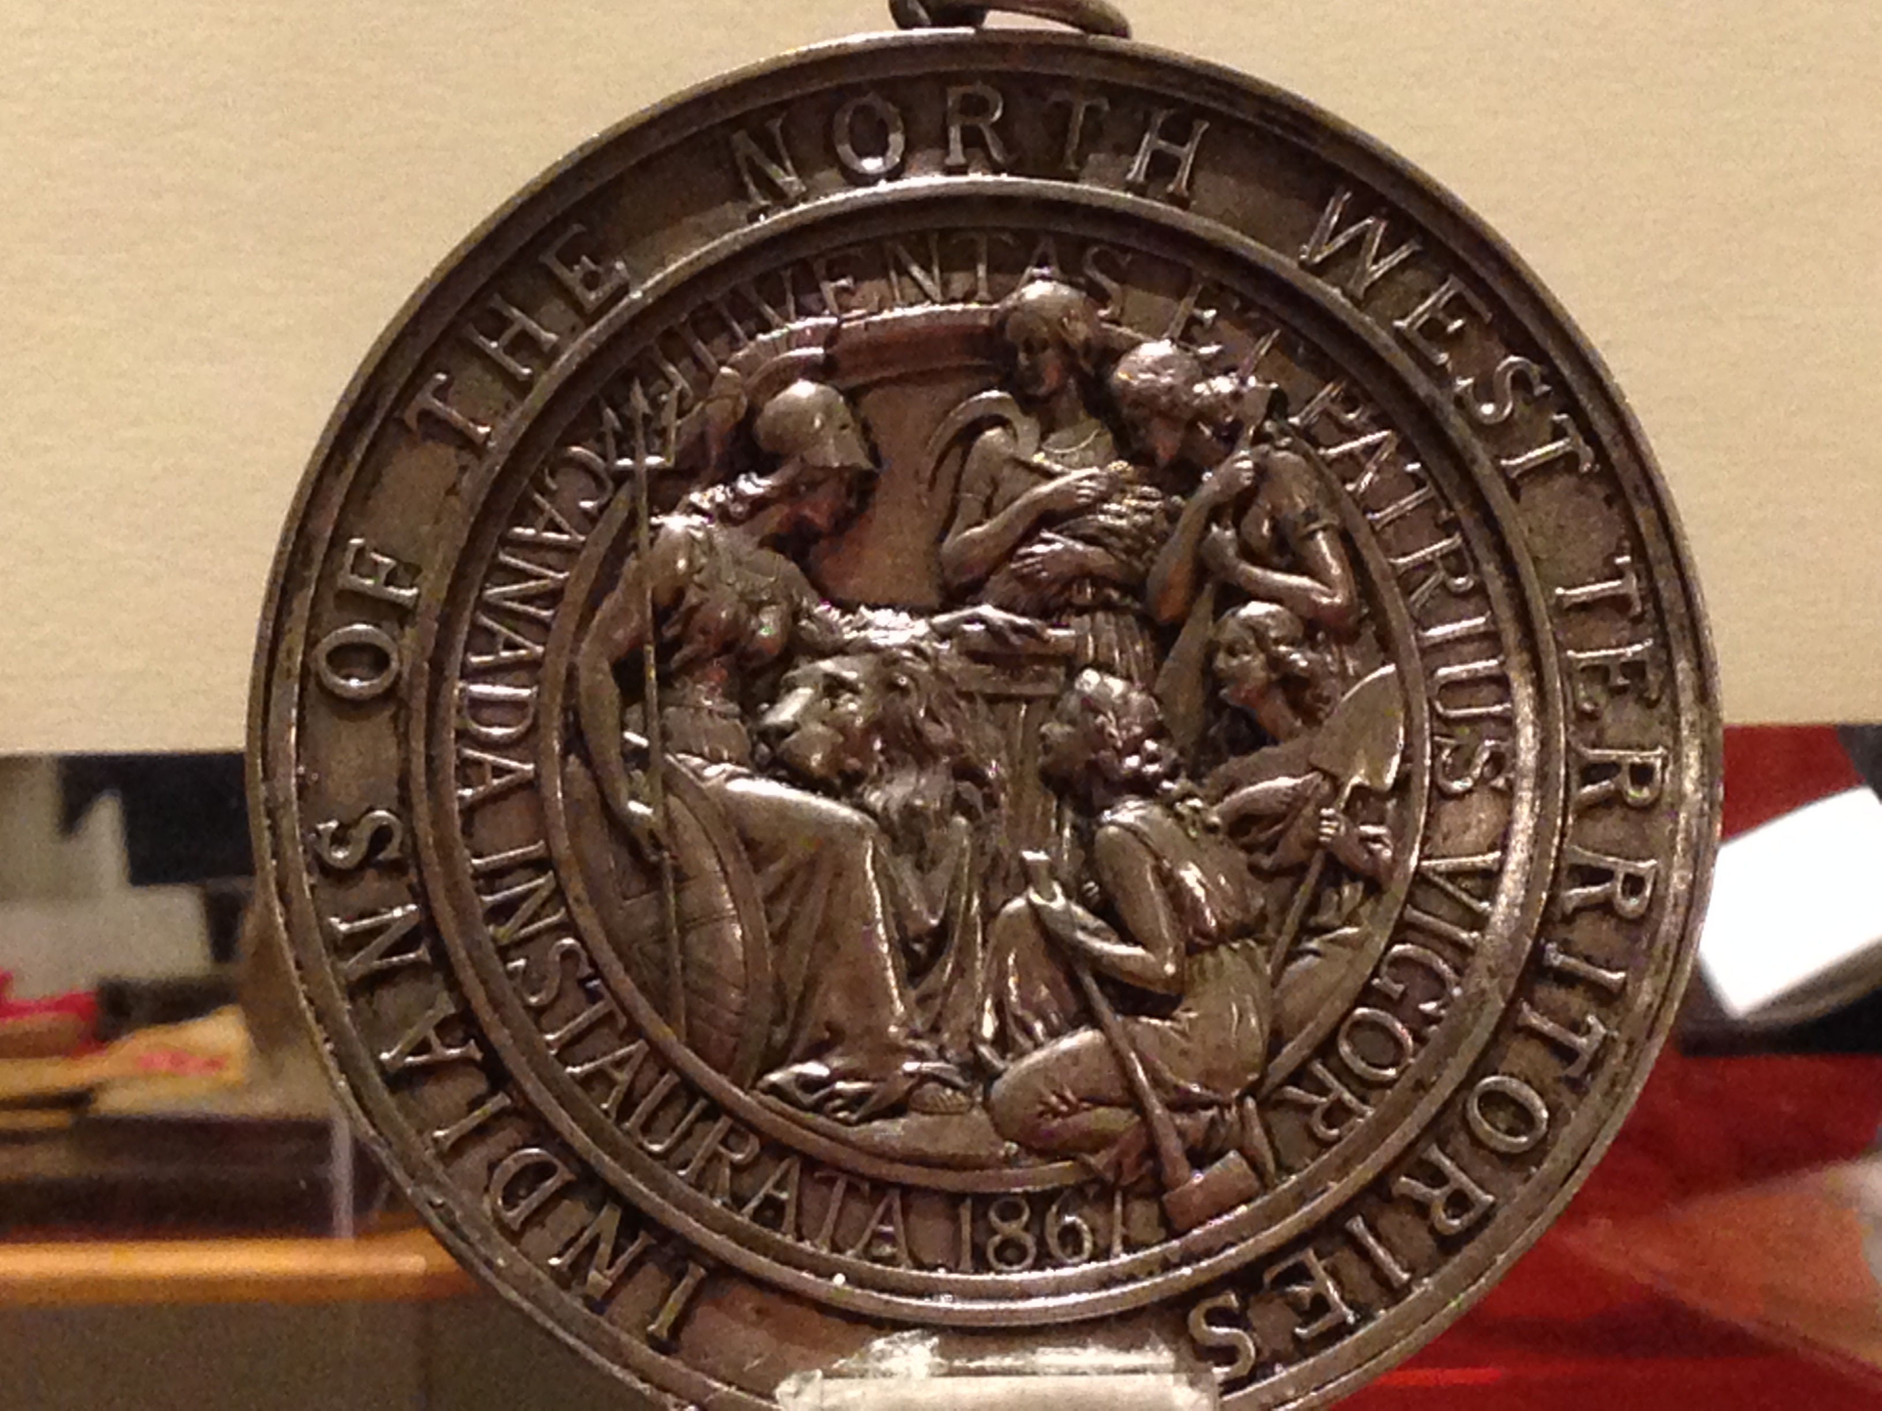
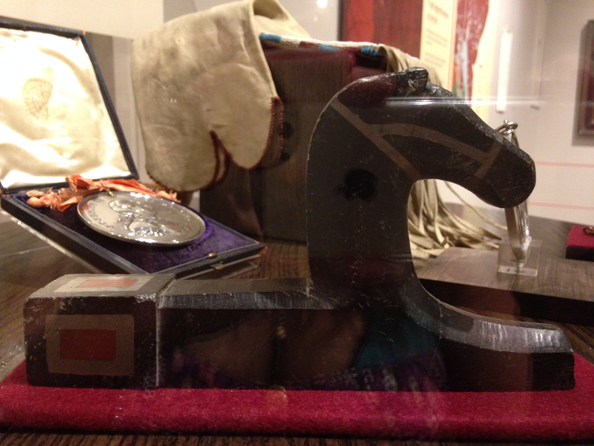
Lest you anger Zeus.
Fly away, Thunderbird.
Lest the snake bite you.
It’s venom poisons, then
Kills.

Turtle Island has flooded.
White waves of destruction
Wash away the past.
Sinking, choking, drowning,
Silencing.

Who will bring up the earth this time?
Who will build the fire?
Who will call forth the spirits to join us once again?

The immortal stone sits quietly in its glass enclosure.
It speaks in soft whispers and vibrations.
It is waiting.

By: Rebecca Reynolds

