Freedoms and Rights
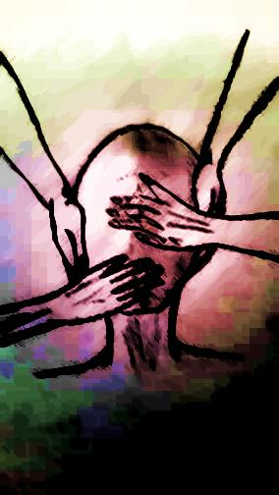
A child’s innocence, fresh-faced and bright,
afforded – no born – with freedoms and rights.
Regardless of colour, sex and race;
regardless of language, religion, birthplace.
But we don’t all receive these freedoms and rights,
Many live in squalor, fear and strife.

It’s not supposed to matter where we live
or which beliefs we hold…
But it does, yes it does, despite what we’re told.

Some people don’t eat; we say ‘that’s life’.
Others get beat; we say ‘not our fight’.
Some are held prisoners for their political stance,
We look the other way, hardly offering a glance.
Some people are homeless; we call them names,
We laugh or dismiss, taunt them to shame.

A voice amongst many, a face in the crowd,
Listen to these words, spoken out loud:

I’m born Filipino, Hindi, German, Cree.
I’m born Irish, French, Jamaican, Greek.

I speak Arabic, Punjabi, Michif, Hebrew,
I believe in God, Allah, I’m an atheist, A Jew.

I’m a girl, a woman, a boy, a man.
I’m black, I’m red, I’m white, yellow, tan.

I am who I am, no more or less than that.
I deserve freedoms and rights, and that is a fact.

Amanda Borton

